adidas sales analysis

# Tools used: MIcrosoft power bi

Problem Statement:

The objective of this assignment is to analyze the Adidas sales database and identify key insights to help improve sales performance and optimize business strategies. By examining the sales data, we aim to understand factors influencing sales, identify trends, and uncover opportunities for growth. The analysis will be conducted using Advanced Power BI visualizations and filters to provide an interactive and insightful dashboard

Dataset Explanation

The Adidas sales database contains the following columns:

* **Retailer:** Represents the business or individual that sells Adidas products directly to consumers.
* **Retailer ID:** A unique identifier assigned to each retailer in the dataset.
* **Invoice Date:** The date when a particular invoice or sales transaction took place.
* **Region:** Refers to a specific geographical area or district where the sales activity or retail operations occur.
* **State:** Represents a specific administrative division or territory within a country.
* **City:** Refers to an urban area or municipality where the sales activity or retail operations are conducted.
* **Gender Type:** Categorization of individuals based on their gender, such as male or female.
* **Product Category:** Represents the classification or grouping of Adidas products.
* **Price per Unit:** The cost or price associated with a single unit of a product.
* **Units Sold:** The quantity or number of units of a particular product sold during a specific sales transaction.
* **Total Sales:** The overall revenue generated from the sales transactions.
* **Operating Profit:** The profit earned by the retailer from its normal business operations.
* **Operating Margin:** A financial metric that indicates the profitability and efficiency of a retailer's operations.
* **Sales Method:** The approach or channel used by the retailer to sell its products or services.
* **Total Rows:** 9648
* **Total Columns:** 14

## Downloading steps:

* **Platform:** Kaggle
* Kaggle provide the python program to extract the dataset from the Kaggle library in python
* Code:

import kagglehub

path = kagglehub.dataset_download("vishwas199728/adidas-sales-data")

print("Path to dataset files:", path)

* 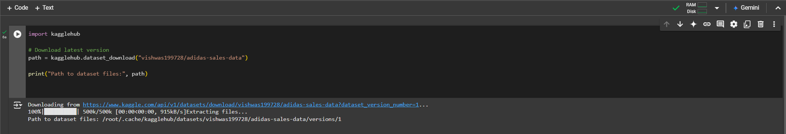Then I used the google colab platform to extract the data
* The output of the program provides the link to download the dataset link
* By using that the dataset had downloaded

### Preprocessing steps:

* Checking of error and empties
* Duplicating the date column to split the days, months and years
* Detecting the data type and correcting the datatype accordingly

### TAble View transformations using dax measures:

* Making general values to currency
* Points to percentage
* Using the DAX measures adding new columns to Sales table
* Using DAX measures measure the important statistical measures

There are:

* **TOtal Profit =** SUM(Sales_details[Operating Profit])
* **Complete Sales =** sum(Sales_details[Total Sales])
* **Avg price per unit =** AVERAGE(Sales_details[Price per Unit])
* **Avg Profit 2020 =** CALCULATE(AVERAGE(Sales_details[Operating Profit]),Sales_details[Year]=2020)
* **Avg Profit 2021 =** CALCULATE(AVERAGE(Sales_details[Operating Profit]),Sales_details[Year]=2021)
* **Total unit sold =** SUM(Sales_details[Units Sold])
* ----------------Column measures-----------------------
* **Profits by cities =** CALCULATE(SUM(Sales_details[Operating Profit]),ALLEXCEPT(Sales_details,Sales_details[City]))
* **Profits by Quater =** CALCULATE(SUM(Sales_details[Operating Profit]),ALLEXCEPT(Sales_details,Sales_details[Quater]))
* **Profits by Retailer =** CALCULATE(SUM(Sales_details[Operating Profit]),ALLEXCEPT(Sales_details,Sales_details[Retailer]))
* **Profits by states =** CALCULATE(SUM(Sales_details[Operating Profit]),ALLEXCEPT(Sales_details,Sales_details[State]))

## REports sheets:

* For this dataset mainly focused Regions, States, Cities
* In that Profits, Sales, Product category, Retailer, Sales method, in all other aspect in the data
* No of sheets are: 3

## Report 1: Region analysis of adidas[2020-2021]

**1.Cards**

* **Purpose:**
  + Large cards display key metrics such as *Total Sales* and *Total Profit*.
  + These visuals highlight crucial performance indicators prominently for quick understanding.

**2. Clustered Bar Chart**

* **Purpose:**
  + Used to compare two metrics (e.g., Sales and Profit) across different categories, such as product categories or retailers.
  + Allows side-by-side comparison to identify which categories or retailers are the most successful.

**3. Donut Charts**

* **Purpose:**
  + Represent the proportion of sales and profit by quarter.
  + Provide a quick visual of how data is distributed as percentages, making it easy to spot dominant time periods.

**4. Combo Chart (Line and Bar Chart)**

* **Purpose:**
  + Combines bar and line charts to show two different metrics (e.g., Sales as bars and Profit as a line) over time or across regions.
  + Highlights trends and relationships between two variables, such as growth in sales and corresponding changes in profit.

**5. Slicers (Checkbox Filters)**

* **Purpose:**
  + Interactive elements for filtering the dashboard by store type (e.g., In-store, Online, Outlet) or region (e.g., Midwest, Northeast, etc.).
  + Provide flexibility for users to customize the view according to their needs.

**6. Thematic Background**

* **Purpose:**
  + 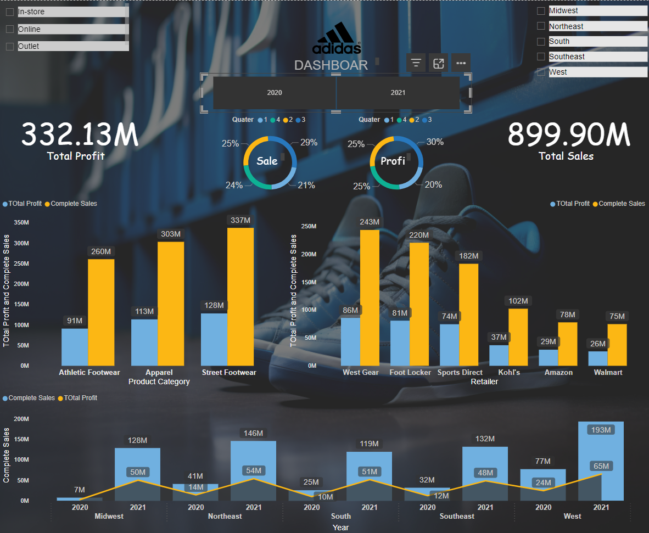An image or brand-specific design (e.g., Adidas logo and shoe image) serves as a background to reinforce the branding and aesthetics of the dashboard.

## Report 2: States analysis of Region

**1.Cards**

* **What It Is:** Large numeric visuals for single value metrics.
* **Purpose:**
  + Display key metrics like *Total Sales*, *Total Profit*, *Average Profit (2020/2021)*, *Total Units Sold*, and *Average Price Per Unit*.
  + Provide at-a-glance insights without needing detailed exploration.

**2. Clustered Bar Chart**

* **What It Is:** A bar chart with multiple series, showing two measures side by side for comparison.
* **Where It's Used:**
  + Comparison of *Complete Sales* and *Total Profit* across *Product Categories* (e.g., Athletic Footwear, Apparel).
  + Retailer-wise breakdown of sales and profits (e.g., Walmart, Amazon, West Gear).
* **Purpose:**
  + Clearly compare multiple metrics across categories or retailers.
  + Identify which category/retailer performs better visually.

**3. Donut Chart**

* **What It Is:** A circular chart representing parts of a whole.
* **Where It's Used:**
  + Sales distribution by gender (Men vs. Women).
* **Purpose:**
  + Visually represent proportions to highlight demographic splits or contributions.

**4. Line and Bar Combo Chart**

* **What It Is:** A combination of a bar chart and a line graph, overlaid on the same axis.
* **Where It's Used:**
  + State-wise performance, showing *Complete Sales* as bars and *Total Profit* as a line.
* **Purpose:**
  + Show the relationship between two metrics over regions (or categories).
  + Identify trends or disparities between metrics like sales and profit.

**5. Slicers**

* **What It Is:** Interactive checkboxes or dropdowns for filtering.
* **Where It's Used:**
  + Filters for store type (*In-store*, *Online*, *Outlet*).
  + Filters for year and quarter selection (e.g., 2020, 2021, Q1–Q4).
* **Purpose:**
  + Provide interactivity, allowing users to customize the dashboard view based on specific dimensions.

**6. Horizontal Segmented Bar Chart**

* **What It Is:** A segmented bar chart laid out horizontally.
* **Where It's Used:**
  + Represents the timeline for year and quarter selection.
* **Purpose:**
  + Acts as a visual time filter, letting users drill down into quarterly data interactively.

**7. Numeric with Units**

* **What It Is:** Card visuals displaying numeric values with units (e.g., $ or M for million).
* **Where It's Used:**
  + Displays *Average Price Per Unit* and *Total Units Sold*.
* **Purpose:**
  + Highlight specific metrics for clarity and emphasize detailed business statistics.

**8. Background and Branding**

* **What It Is:** Thematic background image with Adidas branding and a shoe visual.
* **Purpose:**
  + Enhance dashboard aesthetics.
  + Maintain brand consistency and align visuals with Adidas' identity.

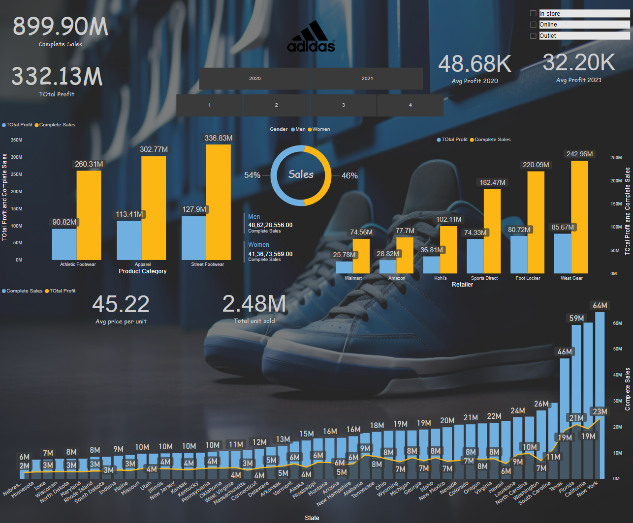

## report 3: Cities analysis of states

**1.Cards**

* **What It Is:** Display single-value metrics such as *Total Profit*, *Complete Sales*, *Total Units Sold*, and *Average Profit for 2020*.
* **Purpose:**
  + Provide a quick summary of essential metrics at the top of the dashboard.
  + Help users immediately understand the overall performance without diving into the details.

**2. Clustered Bar Chart**

* **What It Is:** Side-by-side bars used to compare *Complete Sales* and *Total Profit* for each category or retailer.
* **Where It's Used:**
  + *Product Categories* (e.g., Athletic Footwear, Apparel, Street Footwear).
  + *Retailers* (e.g., Walmart, Amazon, Foot Locker, West Gear).
* **Purpose:**
  + Makes it easy to compare multiple metrics visually.
  + Highlights high-performing categories or retailers for decision-making.

**3. Donut Charts**

* **What It Is:** Circular visuals showing proportions of *Sales* and *Profit* by quarters.
* **Purpose:**
  + Provide an intuitive way to understand quarterly contributions to sales and profit.
  + Use colour coding to emphasize differences across quarters.

**4. Line and Bar Combo Chart**

* **What It Is:** A chart combining bars (*Complete Sales*) and a line graph (*Total Profit*) plotted on the same axis.
* **Where It's Used:**
  + City-wise performance visualization.
* **Purpose:**
  + Highlights the relationship between sales and profit at a regional level.
  + Helps users identify cities that perform well in both metrics.

**5. Slicers (Filters)**

* **What It Is:** Dropdown and checkbox lists for filtering data interactively.
* **Where It's Used:**
  + Filters for *City*, *Year*, *Month*, *State*, and *Sales Method*.
* **Purpose:**
  + Enable users to drill down into specific subsets of data based on location, time, or method of sales.
  + Improve interactivity and customization of the dashboard.

**6. Numeric with Descriptions**

* **What It Is:** Additional numeric cards that include descriptions, e.g., Total Profit and Complete Sales for each product category (Athletic Footwear, Apparel, Street Footwear).
* **Purpose:**
  + Provide further breakdowns of key metrics within product categories.
  + Enable quick reference for more detailed insights.

**7. Horizontal Bar Chart**

* **What It Is:** Horizontal bars showing the city-wise breakdown of metrics.
* **Purpose:**
  + Compare sales or profits across cities more intuitively with horizontal alignment.
  + Focus on granular insights across a wide variety of regions.

**8. Thematic Background**

* **What It Is:** Adidas-branded shoe image as the dashboard's background.
* **Purpose:**
  + Enhances the visual appeal of the dashboard.
  + Ensures the design aligns with Adidas’ brand identity.

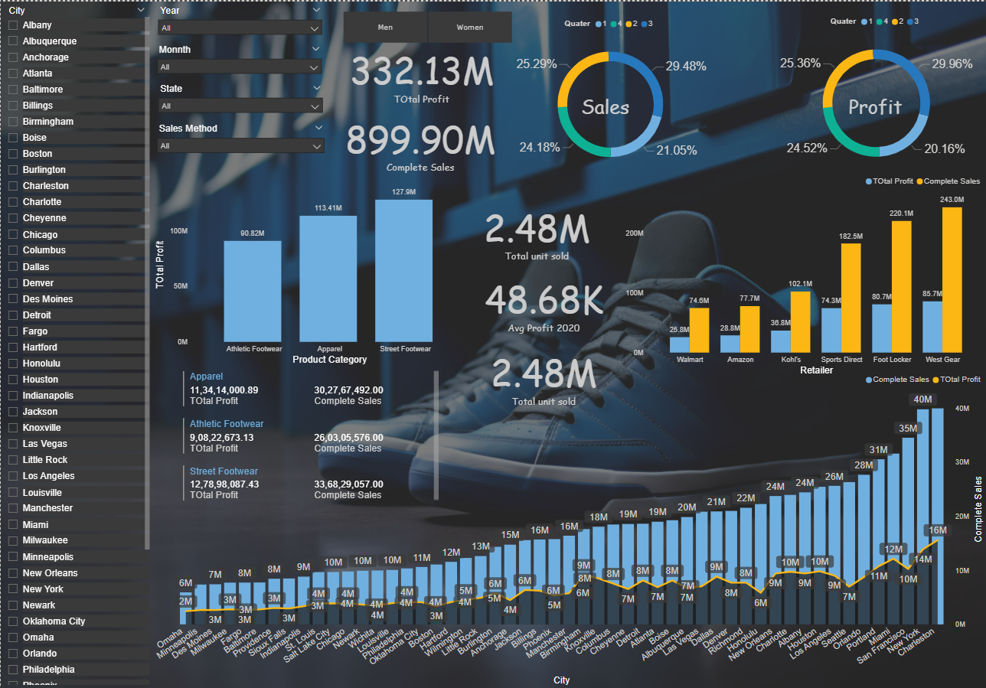

## Overall anaylsis: